**Demonstrate how to create a Collection**

Step-1:

First open postman

Step-2:

Then I click on “+” sign to create a collection

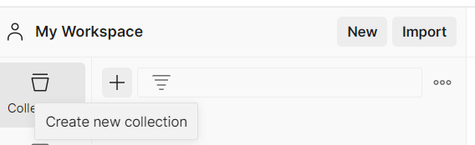

Step-3:

Then I click on Blank Collection

